Generic SO IIR-Filter

Design
This filter is implemented as a direkt implementation of a second order IIR-Filter. However, should the user wish to, the order can be changed by setting the internal constant to something other then three. The following width apply to the different signal paths:
(IN_WIDTH) bits:
- x
(OUT_WIDTH) bits:
- y
(INTERNAL_WIDTH) bits:
- my_mults_in
- my_sum_in
- my_sum_out
- my_mults_out
Note that this means that some information will be lost when my_outputs(0) is written to y. Also, information may be lost in the multiplications and addistions if the user isn't carefull.
During design the following assumptions and limitations were made:
- An equal order of filter coefficients are applied to the input and output signals. If this is not wanted, then the user must fill unwanted coefficients as zero.
- The result will fit into an equal amount of bits as the input is. If this isn't the case, then you can increase the number of bits on the input to increase the output bits as well.
- All internal calculations will fit onto INTERNAL_WIDTH bits. If this isn't the case, some information may be lost.
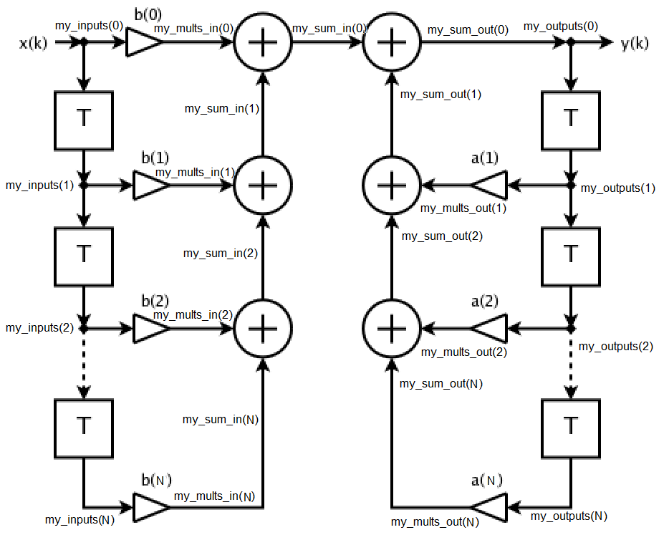

Generics
IN_WIDTH : natural
The width of the input signal
IN_FRACT : natural
The width of the fractional part of the input signal
COEFFICIENT_WIDTH : natural
The width of the filter coefficients
COEFFICIENT_FRACT : natural
The width of the fractional part of the filter coefficients
INTERNAL_WIDTH : natural
The width of internal states of the filter
INTERNAL_FRACT : natural
The width of the fractional part of internal states in the filter
OUT_WIDTH : natural
The width of the output signal
OUT_FRACT : natural
The width of the fractional part of the output signal

Input/Output Signals
clk : in std_logic
System clock
reset : in std_logic
Asynchronous reset that resets when high
x : in std_logic_vector(IN_WIDTH-1 downto 0)
Input signal to be filtered
B0 : in std_logic_vector(COEFFICIENT_WIDTH-1 downto 0)
Coefficient
B1 : in std_logic_vector(COEFFICIENT_WIDTH-1 downto 0)
Coefficient
B2 : in std_logic_vector(COEFFICIENT_WIDTH-1 downto 0)
Coefficient
A1 : in std_logic_vector(COEFFICIENT_WIDTH-1 downto 0)
Coefficient
A2 : in std_logic_vector(COEFFICIENT_WIDTH-1 downto 0)
Coefficient
y : out std_logic_vector(OUT_WIDTH-1 downto 0)
Output signal

Internal Constants
N : integer
Number of coefficients in the filter

Timing
Results from the input is immidiatly put on the output after the next rising flank

